Housing Considerations for the Aged

Frankie E. Glasscock
Department of Family and Consumer Sciences
FACS 300: Interior Design III
Professor Kevin Layell
February 3, 2023

One question that comes to mind when thinking about the future, is what will happen after retirement? What needs will you have as you get older? There is a stigma around assisted living facilities in which most people do not want to go. With putting elders needs in perspective, you can perceive a better understanding why they may be reluctant to leave the comfort of their own home. Assisted living facilities are designed to provide a comfortable environment that provides 24-hour care for those who need a little bit of help to get through the day, whether it be assistance with eating, getting in and out of seating, going to the bathroom, etc. Just a little bit of assistance with each of those tasks can be a huge stress reliever allowing them not to worry about simple everyday tasks that we do every day without thought.
As designers, our goal is to design a space where it feels more like a feeling and connection, rather than just another room. A space should feel connected to you, whether it be by the color of the walls, or the amount of light in the room, or for those who have specific needs, what accommodations there are for them to allow them to feel comfortable. For a senior citizen, it would be scary to leave a place that you call home, which can lead them into not wanting to be placed in an assisted living facility. For them to feel comfortable to leave, they must have a place that feels like home. Assisted living facilities are a great way to showcase how designers can design spaces that can not only accommodate the needs of senior citizens, but also provide a place where it feels like home, and they still have control over their day to day lives.

There are many different needs that each senior citizen must have accommodations for. Whether it be vision, memory, hearing loss, etc., there are many accommodations in which designers must think about when designing an assisted living facility. Through avid research, a study that stood out to me by Gulsah Karaman and Semra Selcuk. The study is titled “Restorative Design Approach for Elderly People: Revisiting Biophilia Hypothesis and Universal Design Principles in Assisted Living Facilities”. In this study it talks about designing spaces that the elders can connect with. The biophilic design states that space has a healing effect on people, and it has social and psychological improvement (Karaman and Selcuk 1). There is a table in the journal that includes examples of biophilic design. One of the examples is visual connection with nature, which would be a window with a landscape view or interior flowers (Karaman and Selcuk 21). The biophilic design tragedy can help incorporate connections with nature in a space. Karaman and Selcuk did a great job showing how biophilic design can affect different aspects.
Other designs discussed in the study was universal design. Some of the universal design strategies for an assisted living facility included entrances with ramps, ADA style bathrooms, contrast of colors within the spaces, non-slip soft flooring, automatic doors, and multi-level countertops. Some of these universal and biophilic principles were applied to an assisted living facility in Spokane, Washington. The assisted living facility is called Rockwood Retirement. Rockwood retirement understood what the residents needed and made some changes. The Rockwood community has seven patterns that they follow, a healthy mind and body, social connections, lifelong learning, financial well-being, mindfulness, fun and entertainment, and spirituality (Karaman and Selcuk 22). These patterns were applied to spaces such as an indoor swimming pool, a business and arts center, a wellness center, a library, ballroom, and an outdoor dining area. The facility also has a wonderful view of the mountains and Spokane River. Concluding research in this study shows how the Rockwood Retirement community took in account the residents need and wanted them to establish a connection with their living environment. Through their study, there is research that has found how connection with nature can have a positive affect mental and social health.
Another research study that I came across while researching design solutions for the elderly, is titled “Chromatic Interior Environments for the Elderly: A Literature Review” by Anna Carda, Ana Barchino, and Juan Lluch. In this study, they explore the way the elderly perceives and interact with spaces. Working through different impairments that the elderly may have; they study solutions on what would be the best design solution to accommodate those needs. One impairment that is discussed in the study is vision. Impairment of the vision can affect many different things such as mobility, and how they perceive color. In a table from the study, it shows different shades of colors, and how they may be confusing when using them together. One way this impairment could be accommodated for is the use of light. Light can change the way colors can be perceived, whether it be by making the color appear brighter, or dulling the color in which could be confusing to understand. To better understand color perception effects in aging is necessary to see how it may influence the way the elderly perceive their environment (Carda et al. 393). Sometimes the simplest modifications can make someone’s everyday life so much easier. As shown in this study, just understanding how the elderly perceive color can allow designers to design a space where the elderly can still have a connection with their environment and interact with the colors they see.

Throughout my research, I have seen the many different health problems some elders have to deal with every day. Like I mentioned in the last article, one of them being vision impairments, but also problems such as dementia, and motor ability. Assisted living facilities are designed to take care of those needs and provide the residents with the upmost best experience that they can have there to feel like home. Nothing compares to the comfort of your own home, but with these little design strategies, the stress-free everyday life can be all the worth it. There are so many great options for assisted living facilities throughout the states, all with their own design solutions and ways to provide the best experience for all who live there.
An article that stood out to me in my research was creating a dementia-friendly environment in assisted living facilities using nature. I have seen many ways how nature can have a positive effect on different needs. From a personal experience, one of the best ways to stay positive and clear minded, is to be outside in nature, whether be for a ten-minute walk, or hanging out there all day, it can make a difference in elevating your mood and providing a stress reliever at the same time. One sentence that was mentioned in the article is that the outdoor natural landscapes can have positive effects on the agitation, apathy, and engagement of people with dementia (Motealleh et al. Dupre 1). Some initiatives that were taken to help people with dementia are creating an outdoor space with a natural landscape and activities they can interact with such as farming or gardening activities. While designing a space like this, there are several things that must be considered such as how will the space be designed? What will be included in the space, whether it be above ground planter boxes, roundabouts, fountains, etc. Another question to consider is the accessibility of the space. Will there be any ramps or all even surfaces? Where will the handrails be? Lastly, what activities will be set in place for the residents to be able to participate in? Gardening, small farming, building small projects is a great way to not only increase their overall moods but allow them to feel productive and relaxed.
In the article mentioned above, nature was shown to have a positive effect on residents, what other design solutions are there to support a positive environment in the assisted living facility? Federal Regulation codes specify that the physical environment be “safe, clean, functional, comfortable, and homelike allowing the resident to use personal belongings to the extent possible” (Cutler 1). In an article “Physical Environments of Assisted Living”, problematic design decisions were listed. These were problems that the designers ran into or noticed needed to be fixed. Some of those problems included no operable windows in the dining room, no individual climate controls in rooms, units needed doors separating the bathroom and living room, and that it was difficult to create a homelike setting in large multi-use rooms (Cutler 1). Looking at these design problems, I can personally agree that these are things that should be considered on being completed because it would create a better space. One detail that stood out to me was in a study mentioned in the article, they found that colored way-finding techniques were not successful, and the residents preferred a staff member to orient them instead. That stood out to me because I personally thought way-finding signs would be helpful and allow you to go places on your own without staff, but now I can understand that maybe some do not have the best vision or get confused by the signs even if they have arrows or numbers to point them where to go. Even now with the wayfinding in college hallways, the wayfinding’s can be really confusing even with all the arrows, numbers, and maps.
In the previous paragraphs, I have mentioned design solutions for different impairments and needs, now I want to mention the more technicality of the design interior of the assisted living facilities. Continuing with design solutions, here are a few that I have found in an article talking about designing long term care facilities. One bullet point was to design spaces to allow residents to move freely within the space from one room to another without having to use a corridor (Wrublowsky 10). This is important because sometimes walls to close can pose a risk if the resident was to fall, whereas an open floor would allow room for such accidents. Other bullet points included providing opportunities for intimate and private conversation that are comfortable (Wrublowsky 10). Designing private spaces should be included because even though it is a facility where others are living, does not mean there should not be spaces where you can go and talk with someone privately without distraction. When designing a floor plan for the assisted living facility, the spaces should be split into groups so the viewer can see public and private spaces, outdoor spaces, etc.
As a designer, the goal is to design a space not primarily just for the look, but mainly to provide a space that the client needs. It is important to understand the client’s needs and use of what you are building, so you can get a better understanding of what you are designing. As a Christian, our goal is meet the needs of others. Not focusing on the needs of ourselves, but instead giving it to our neighbor. In Mark 12:31 it says, “Love thy neighbor as yourself”. The meaning of that verse is so important for we cannot love our neighbor with compassion and kindness, until we are these things to ourselves. Another verse that stands out to me is Proverbs 24:3-4, “By wisdom a house is built, and by understanding it is established, by knowledge the rooms are filled with all precious and pleasant riches”. The meaning of this verse is that our foundation or house is to be built on wisdom and understanding. With the same we should show wisdom and understanding as we are working with clients. Letting them know we understand them, asking them how we can meet their needs, for we are not designing for our own pleasures but for their own.
After researching, I have learned many different things. Not only as a designer, but as the life of an older individual. Design is not simply making things aesthetic, and nice to look at, it is deeper, it is learning and understanding of the people you are designing for. Whether it the needs they have, the culture, the use, etc. Our calling to design a space that is more meaningful. Learning about the different impairments of older individuals, I can understand how if a space was not designed correctly, could make your day-to-day life stressful and cause you to have negative moods. It is important to understand that your environment will affect your overall mood and productiveness. Incorporating elements such as nature into the facility is a great way to uplift and provide a stress-free environment. What I hope to take from this research is apply what techniques I have learned and design problems to design an assisted living space that is focused on the needs of the residents. I want to end this research paper with a final bible verse from 1 Peter 4:10, “Each one should use whatever gift he has received to serve others, faithfully administering God’s grace in its various forms”.

Appendix
Figure 1.1
Title: Rockwood Retirement Community
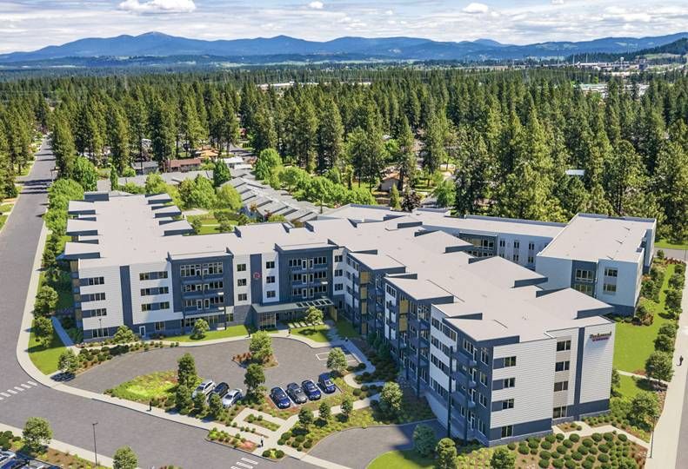
Note: 420, 000 sq. ft, Assisted Living Facility, that includes three dining venues, an event center for large-scale lectures and dances, an exercise facility, a movie theater, an art studio, and a salon and spa.

Credit: (NAC Architecture)

Figure 1.2
Title: Rockwood Retirement Community Outdoor Space
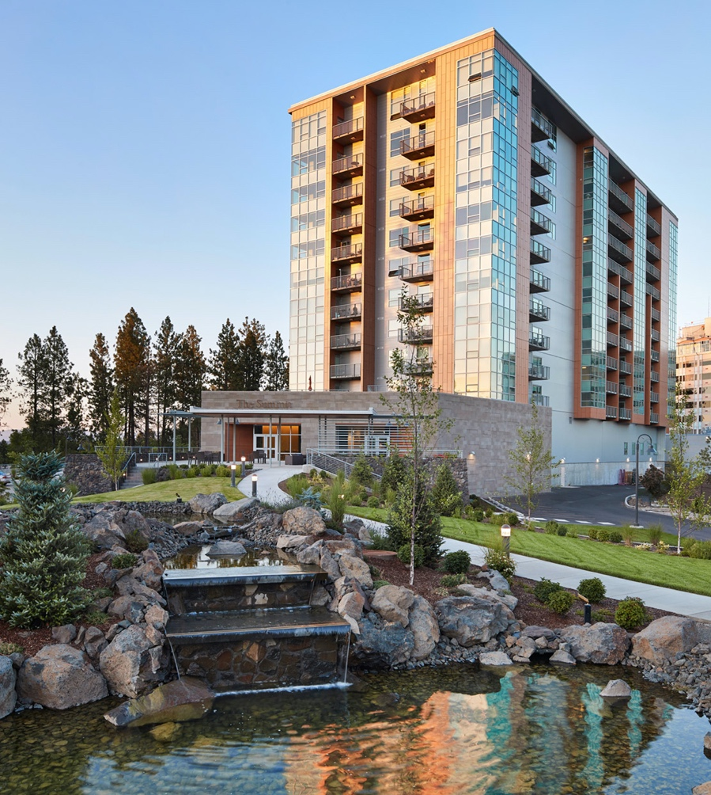
Note: Rockwood Retirement Community’s exceptional outdoor space that includes lots of greenery and a beautiful view of a fountain trickling into a pond.

Credit: (NAC Architecture)

Figure 2.1
Title: The Watermark at Westwood Village
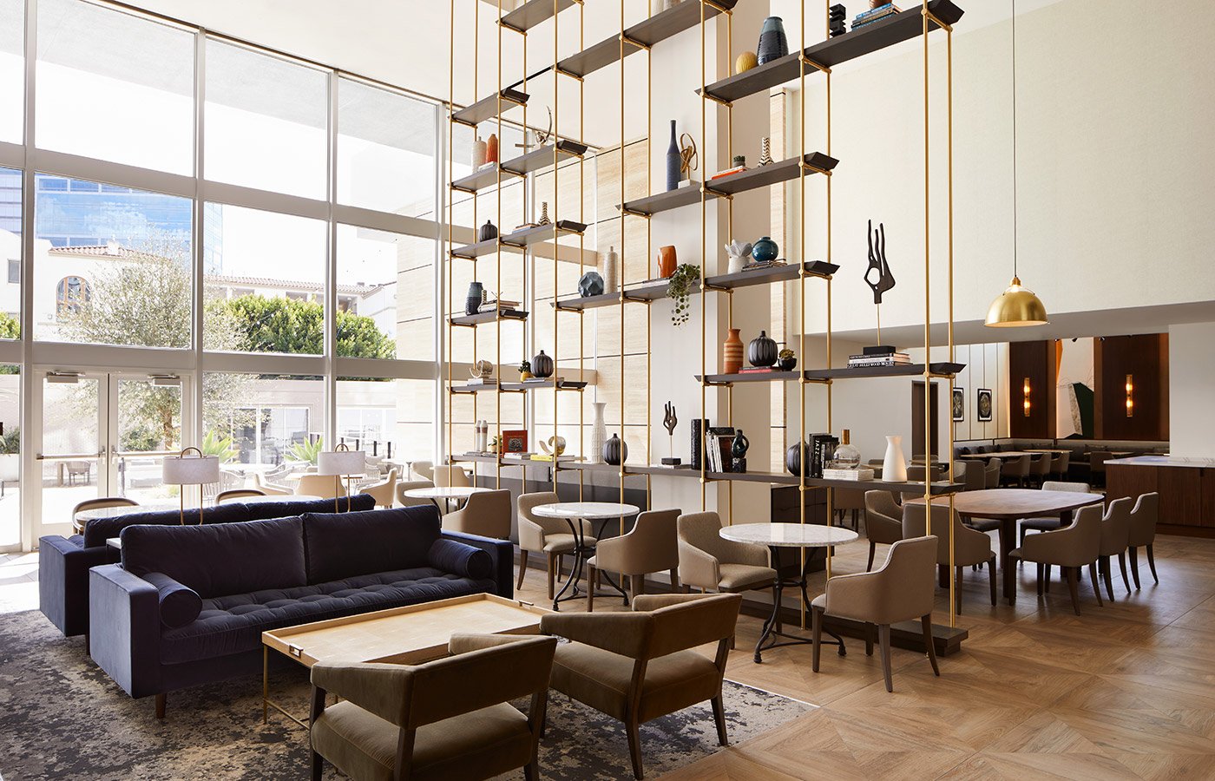

Note: The Watermark at Westwood Village is an assisted living facility in Los Angeles, CA. Including a range of living choices such as independent living, assisted living, memory care, or short-term stays.

Credit: Watermark Retirement Communities

References
Carda , A., Barchino , A., & Lluch, J. (2019, January 17). Chromatic interior environments for the elderly: A literature review ... Chromatic interior environments for the elderly: A literature review. Retrieved February 6, 2023, from https://onlinelibrary.wiley.com/doi/10.1002/col.22358
Cutler , L. (2007, December 1). Physical Environments of Assisted Living: Research Needs and Challenges. Retrieved February 5, 2023, from https://academic.oup.com/gerontologist/article/47/suppl_1/68/614186
Hendrickson Publishers Marketing, LLC. (2020). The Holy Bible: King James Version.
Karaman , G., & Selcuk , S. (2020, December 23). Journal of Science - DergiPark. Retrieved February 6, 2023, from https://dergipark.org.tr/en/download/article-file/1462541
Moteallah , P., Moyle , W., Jones , C., & Dupre , K. (2019, June 18). Creating a dementia-friendly environment through the use of outdoor natural landscape design intervention in long-term care facilities: A narrative review. Retrieved February 5, 2023, from https://www.sciencedirect.com/science/article/pii/S1353829218309456?casa_token=wgAjPo4nyGcAAAAA%3A7k8xpSJZ_27lv7YOnimlcGwyG_8UI89zNQLCyiLzbKpbtAbYnTLF0BFRCwugjXr4cTm06Qo4Tw
Wrublowsky , R. (2017). Facility Guidelines Institute. Design Guide for Long-Term Care Homes. Retrieved February 6, 2023, from https://www.fgiguidelines.org/wp-content/uploads/2018/03/MMP_DesignGuideLongTermCareHomes_2018.01.pdf

